**9. RC PHASE SHIFT OSCILLATOR**

**AIM:** To find the frequency of oscillations of the RC phase Shift oscillator and to measure the phase shift of each Section of the RC network.

**APPARATUS**

1. Transistor BC 107,
2. Resistors – 4.7KΩ (2), 33KΩ (1),2.2KΩ (1),

8.2KΩ (1) and 2.7KΩ (1).

1. Capacitors – 0.01μf (3) & 47μf(1),
2. Potentiometer 10KΩ (1),
3. Regulated Power Supply,
4. CRO with probes, 7. Bread Board & wires.

**CIRCUIT DIAGRAM** :

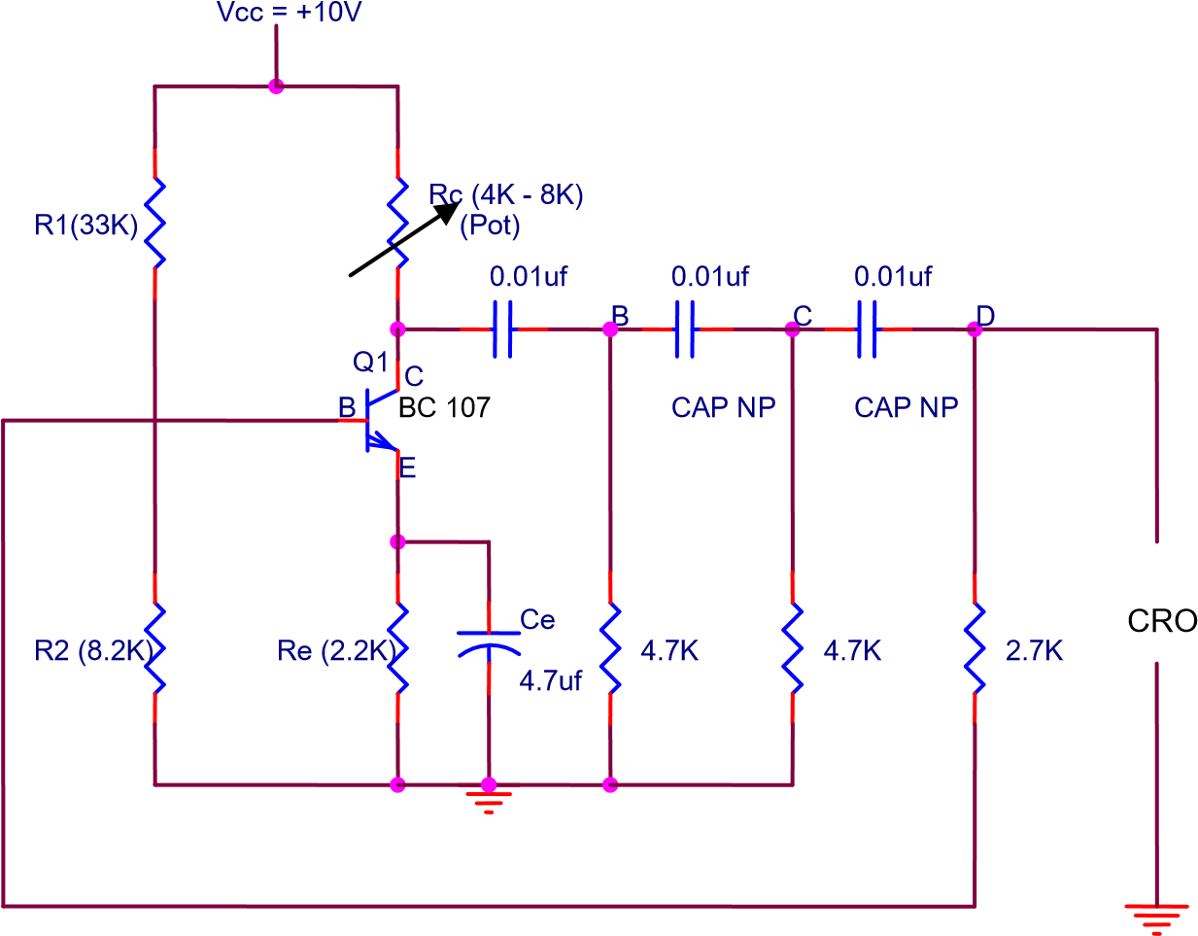

# RC PHASE SHIFT OSCILLATOR

**PROCEDURE** :

1. Connections are made as per the circuit diagram.
2. Set the value of Rc (4KΩ – 8KΩ) by varying DRB and observe the output waveform at ‘0’ on CRO which is sinusoidal.
3. Now, the CRO probe is changed to position ‘B’ such that the output Waveform at B is observed on CRO which is shifted by 60o w.r.t ‘0’.
4. The output waveform at ‘C’ is observed on CRO, which is shifted by 120 o w.r.t ‘0’.

5 . The output waveform at ‘D’ is observed on CRO, which is shifted by 180o w.r.t ‘0’.

1. Theoretically the frequency of oscillations is calculated by the formula, **f=1/2חRC√6+4K, K = RC / R**

Practically the time period ‘T’ on CRO is noted and frequency **f = 1/T** is calculated.

1. The readings for different values of RC at 4K,5K,6K,7K and 8K are noted And are tabulated as shown in the tabular form for different Lissajous pattern.
2. A graph is plotted for phase and amplitude locating the phase shift observed On CRO at different positions of (B,C,D).

**OBSERVATION :**

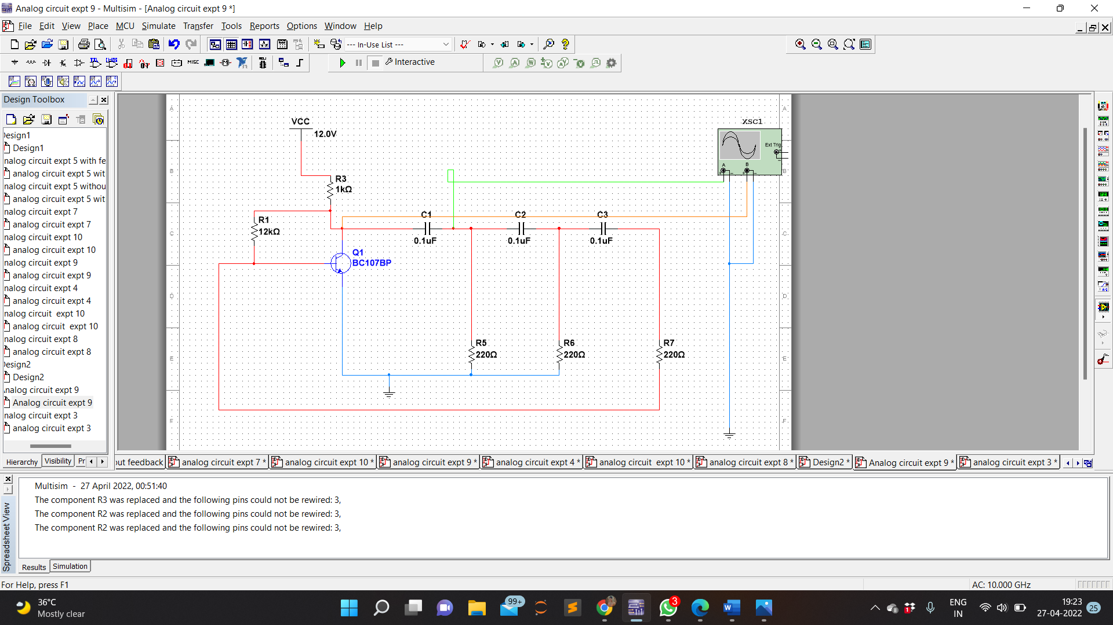CIRCUIT DIAGRAM

**WAVEFORMS**

POSITION B W.R.T COLLECTOR

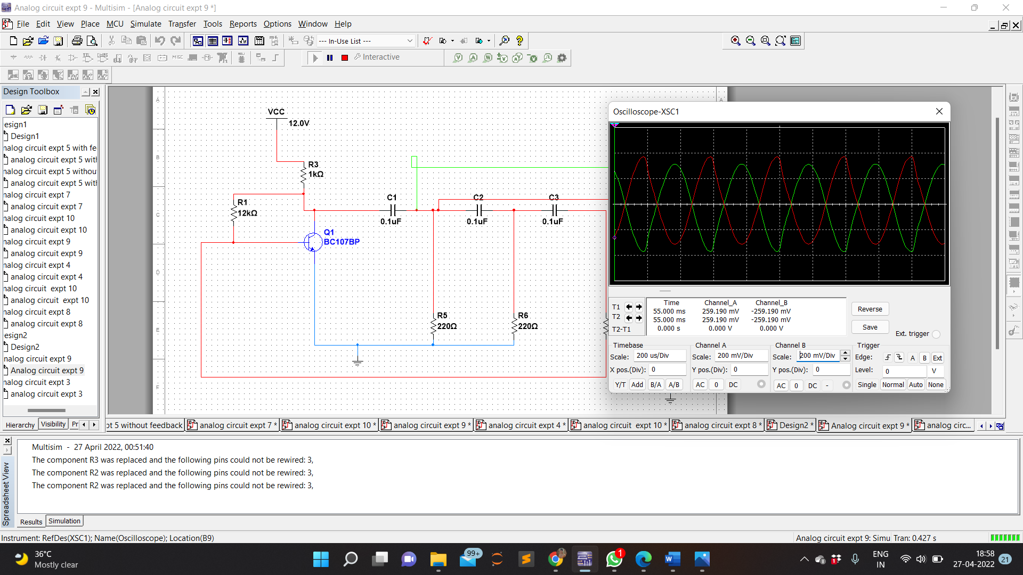

POSITION C W.R.T COLLECTOR

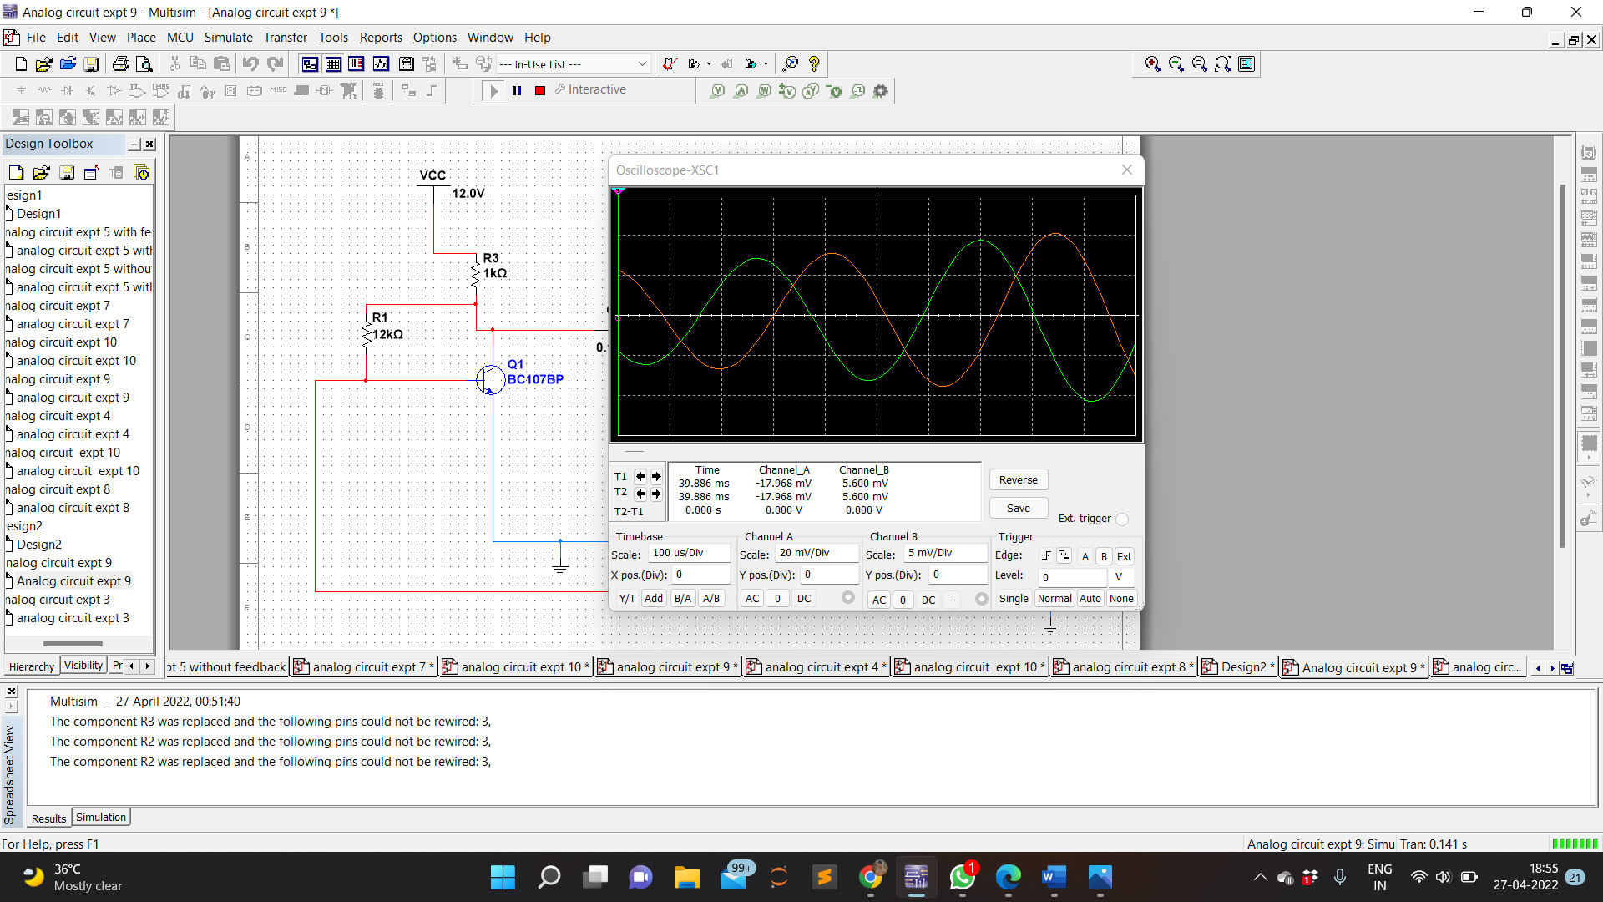

POSITION D W.R.T COLLECTOR

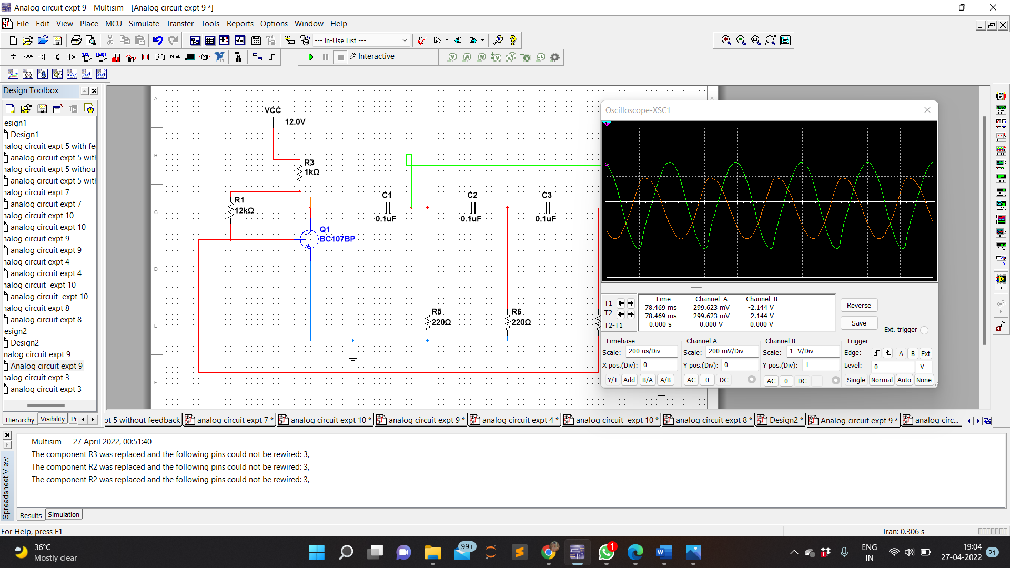

**CALCULATION :**

K=RC/R= 220/330 = 2/3=0.67

R=330ohm, C=0.1𝜇F

f= 1/ 2𝜋𝑅𝐶√6+4𝐾 = 1 /2𝜋330×0.1×10−6×√6+4𝐾 =1.6387KHz

T=1/f=610.23𝜇𝑠

(i)Y1=6, Y2=6

θ = sin−1 ( 𝑌1/ 𝑌2 )=90°

(ii)Y1=7, Y2=8

θ = sin−1 ( 𝑌1/ 𝑌2 )=61.04°

(iii)Y1=6, Y2=12

θ = sin−1 ( 𝑌1/ 𝑌2 )=30°

**TABULAR FORM** :

|  |  |  |  |  |  |  |  |  |
| --- | --- | --- | --- | --- | --- | --- | --- | --- |
| **S.NO** | **RC (KΩ)** | **Position**  **w.r.t**  **Collector** | **Lissajous**  **Pattern** | **Y1 (V)** | **Y2 (V)** | **θ=Sin-1**  **(Y1 /Y 2)** | **T (Sec)** | **f0 (Hz)**  **Theoretical** |
| 1 | 4.7K**Ω** | **B**  **C**  **D** | Φ =0  0< Φ<90  90 < Φ  <180 | 6  7  6 | 6  8  12 | 90  61.04  30 | 610.23 us  610.23 us  610.23 us | 1.6387 KHz  1.6387 KHz  1.6387 KHz |

**LISSAZEOUS PATTERN:**

Φ =00 0< Φ<900 Φ=900 900< Φ<1800 Φ=1800

**x**

**1**

**x**

**2**

**x**

**1**

**x**

**2**

**X**

**Y**

**Major Axis**

**MODEL GRAPH: OUTPUT WAVEFORMS**

at B

at O

at C

at O

at O

at D

Amp(V)

Amp(V)

Amp(V)

Time(sec)

Time(sec)

Time(sec)

∆t

∆t

∆t

POSITION B W.R.T COLLECTOR

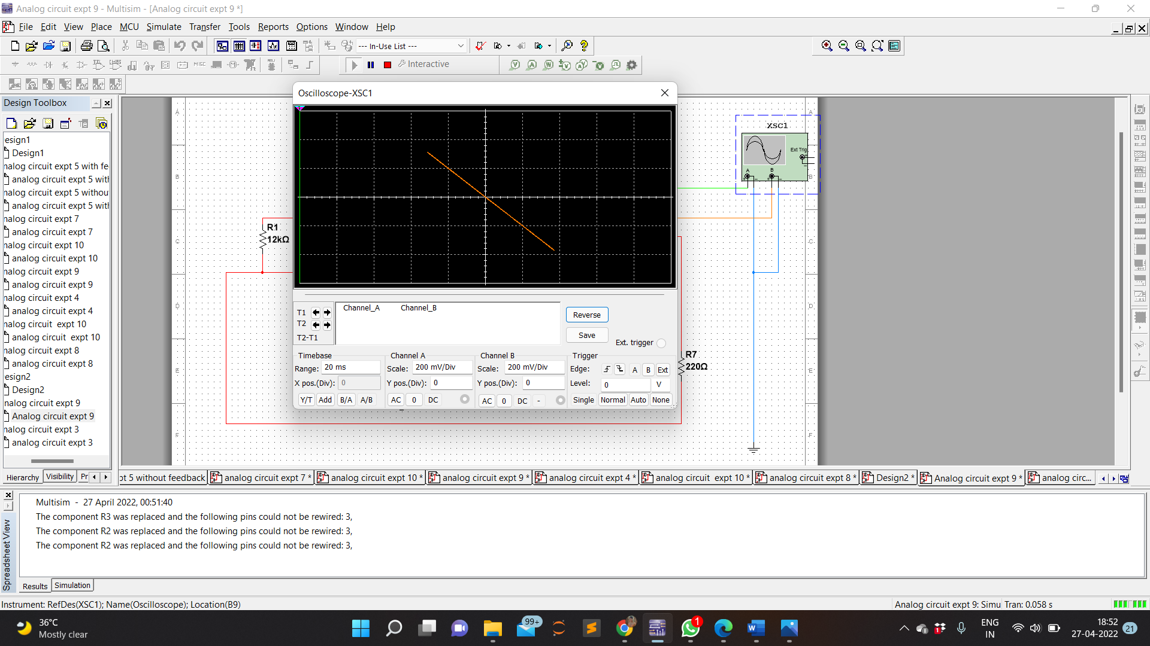

POSITION C W.R.T COLLECTOR

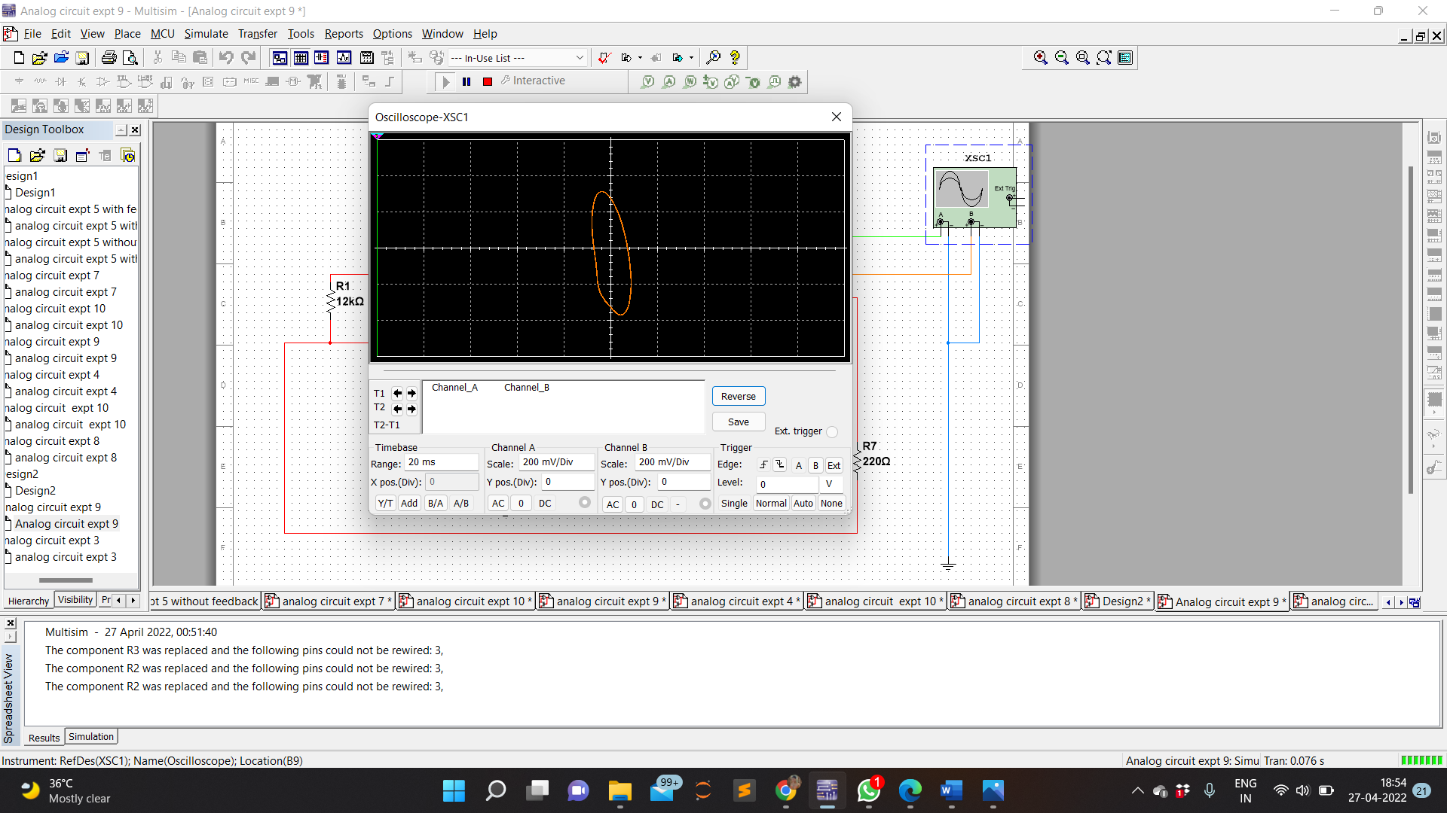

POSITION D W.R.T COLLECTOR

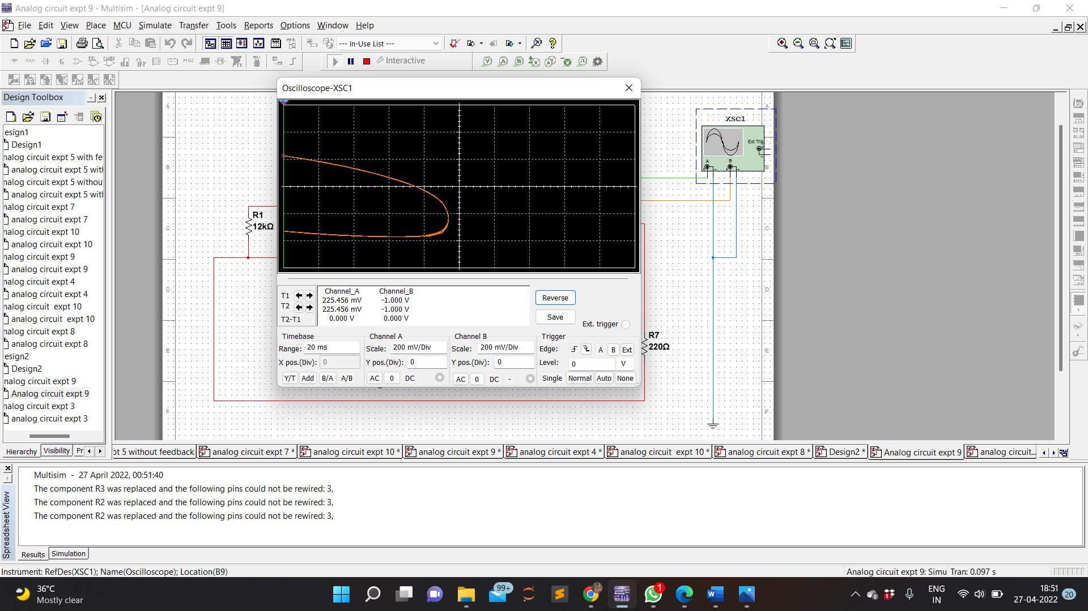

**PRECAUTIONS**: 1. The readings are to be noted down without parallax error.

2. Wrong connections should be avoided.

**RESULT:**

Frequency of oscillations of the RC phase Shift oscillator and the phase shift of each Section of the RC network has been studied and calculated through the designed circuit.